

QPiiARIAT DPRn KQTA MAI.ANG

LEMBAR DISPOSISI UNDANGAN

* P.nkot

# Yqdllllldq

bl Unclqan

: OOSl1330/3S.73.502/20ll

: 29 Junl 2021

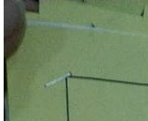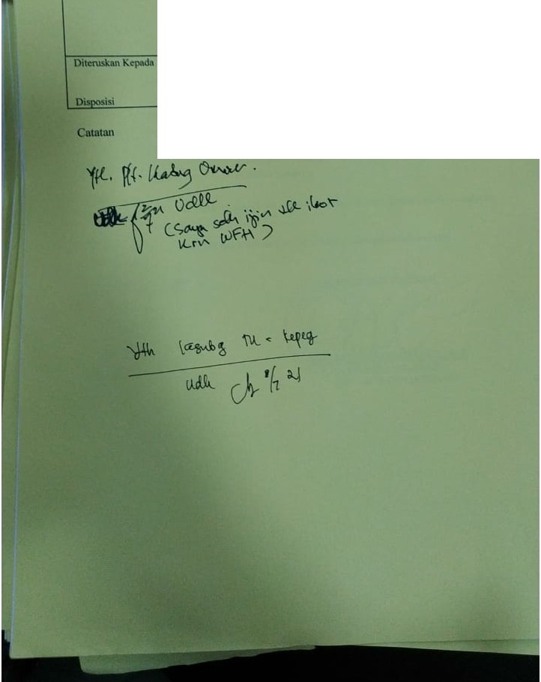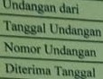

: Ylh Set DprdKola Ma\q

209